DBMS UNIT -5 REG NO:

Distributed database

In a distributed database, there are a number of databases that may be geographically distributed all over the world. A distributed DBMS manages the distributed database in a manner so that it appears as one single database to users.
A distributed database is a collection of multiple interconnected databases, which are spread physically across various locations that communicate via a computer network. Distributed database is a system in which storage devices are not connected to a common processing unit. Database is controlled by Distributed Database Management System and data may be stored at the same location or spread over the interconnected network. It is a loosely coupled system. Shared nothing architecture is used in distributed databases.
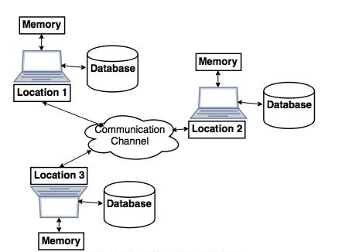

Features:
- Databases in the collection are logically interrelated with each other. Often they represent a single logical database.
- Data is physically stored across multiple sites. Data in each site can be managed by a DBMS independent of the other sites.
- The processors in the sites are connected via a network. They do not have any multiprocessor configuration.
- A distributed database is not a loosely connected file system.
- A distributed database incorporates transaction processing, but it is not synonymous with a transaction processing system.

Distributed Database Management System:
A distributed database management system (DDBMS) is a centralized software system that manages a distributed database in a manner as if it were all stored in a single location.

Features:
- It is used to create, retrieve, update and delete distributed databases.
- It synchronizes the database periodically and provides access mechanisms by the virtue of which the distribution becomes transparent to the users.
- It ensures that the data modified at any site is universally updated.
- It is used in application areas where large volumes of data are processed and accessed by numerous users simultaneously.
- It is designed for heterogeneous database platforms.
- It maintains confidentiality and data integrity of the databases.

Factors Encouraging DDBMS:
The following factors encourage moving over to DDBMS −
- Distributed Nature of Organizational Units − Most organizations in the current times are subdivided into multiple units that are physically distributed over the globe. Each unit requires its own set of local data. Thus, the overall database of the organization becomes distributed.
- Need for Sharing of Data − The multiple organizational units often need to communicate with each other and share their data and resources. This demands common databases or replicated databases that should be used in a synchronized manner.
- Support for Both OLTP and OLAP − Online Transaction Processing (OLTP) and Online Analytical Processing (OLAP) work upon diversified systems which may have common data. Distributed database systems aid both these processing by providing synchronized data.
- Database Recovery − One of the common techniques used in DDBMS is replication of data across different sites. Replication of data automatically helps in data recovery if database in any site is damaged. Users can access data from other sites while the damaged site is being reconstructed. Thus, database failure may become almost inconspicuous to users.
- Support for Multiple Application Software − Most organizations use a variety of application software each with its specific database support. DDBMS provides a uniform functionality for using the same data among different platforms.

Advantages of Distributed Databases:
Following are the advantages of distributed databases over centralized databases.
Modular Development − If the system needs to be expanded to new locations or new units, in centralized database systems, the action requires substantial efforts and disruption in the existing functioning. However, in distributed databases, the work simply requires adding new computers and local data to the new site and finally connecting them to the distributed system, with no interruption in current functions.
More Reliable − In case of database failures, the total system of centralized databases comes to a halt. However, in distributed systems, when a component fails, the functioning of the system continues may be at a reduced performance. Hence DDBMS is more reliable.
Better Response − If data is distributed in an efficient manner, then user requests can be met from local data itself, thus providing faster response. On the other hand, in centralized systems, all queries have to pass through the central computer for processing, which increases the response time.
Lower Communication Cost − In distributed database systems, if data is located locally where it is mostly used, then the communication costs for data manipulation can be minimized. This is not feasible in centralized systems.

Adversities of Distributed Databases:
Following are some of the adversities associated with distributed databases.
- Need for complex and expensive software − DDBMS demands complex and often expensive software to provide data transparency and co-ordination across the several sites.
- Processing overhead − Even simple operations may require a large number of communications and additional calculations to provide uniformity in data across the sites.
- Data integrity − The need for updating data in multiple sites pose problems of data integrity.
- Overheads for improper data distribution − Responsiveness of queries is largely dependent upon proper data distribution. Improper data distribution often leads to very slow response to user requests.

Types of Distributed Databases:
Distributed databases can be broadly classified into homogeneous and heterogeneous distributed database environments, each with further sub-divisions, as shown in the following illustration.
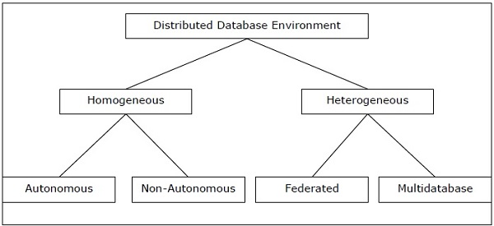

Homogeneous Distributed Databases:
In a homogeneous distributed database, all the sites use identical DBMS and operating systems. Its properties are −
- The sites use very similar software.
- The sites use identical DBMS or DBMS from the same vendor.
- Each site is aware of all other sites and cooperates with other sites to process user requests.
- The database is accessed through a single interface as if it is a single database.

Types of Homogeneous Distributed Database:
There are two types of homogeneous distributed database −
- Autonomous − Each database is independent that functions on its own. They are integrated by a controlling application and use message passing to share data updates.
- Non-autonomous − Data is distributed across the homogeneous nodes and a central or master DBMS co-ordinates data updates across the sites.

Heterogeneous Distributed Databases:
In a heterogeneous distributed database, different sites have different operating systems, DBMS products and data models. Its properties are −
- Different sites use dissimilar schemas and software.
- The system may be composed of a variety of DBMSs like relational, network, hierarchical or object oriented.
- Query processing is complex due to dissimilar schemas.
- Transaction processing is complex due to dissimilar software.
- A site may not be aware of other sites and so there is limited co-operation in processing user requests.

Types of Heterogeneous Distributed Databases:
- Federated − The heterogeneous database systems are independent in nature and integrated together so that they function as a single database system.
- Un-federated − The database systems employ a central coordinating module through which the databases are accessed.

Distributed DBMS Architectures:
DDBMS architectures are generally developed depending on three parameters −
- Distribution − It states the physical distribution of data across the different sites.
- Autonomy − It indicates the distribution of control of the database system and the degree to which each constituent DBMS can operate independently.
- Heterogeneity − It refers to the uniformity or dissimilarity of the data models, system components and databases.

Architectural Models:
Some of the common architectural models are −
- Client - Server Architecture for DDBMS
- Peer - to - Peer Architecture for DDBMS
- Multi - DBMS Architecture

Client - Server Architecture for DDBMS:
This is a two-level architecture where the functionality is divided into servers and clients. The server functions primarily encompass data management, query processing, optimization and transaction management. Client functions include mainly user interface. However, they have some functions like consistency checking and transaction management.
The two different client - server architecture are −
- Single Server Multiple Client
- Multiple Server Multiple Client (shown in the following diagram)
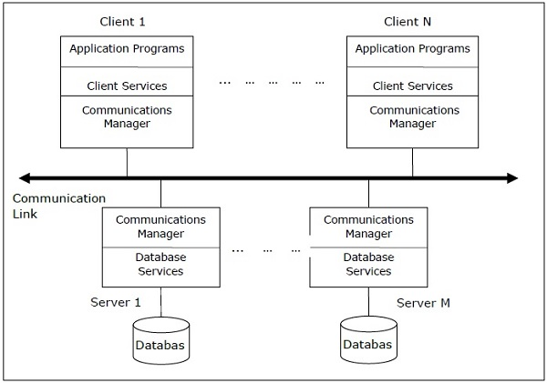

Peer- to-Peer Architecture for DDBMS:
In these systems, each peer acts both as a client and a server for imparting database services. The peers share their resource with other peers and co-ordinate their activities.
This architecture generally has four levels of schemas −
- Global Conceptual Schema − Depicts the global logical view of data.
- Local Conceptual Schema − Depicts logical data organization at each site.
- Local Internal Schema − Depicts physical data organization at each site.
- External Schema − Depicts user view of data.
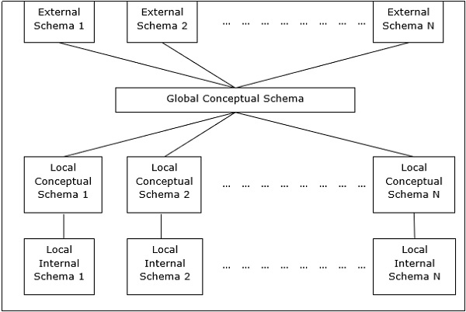

Multi - DBMS Architectures:
This is an integrated database system formed by a collection of two or more autonomous database systems.
Multi-DBMS can be expressed through six levels of schemas −
- Multi-database View Level − Depicts multiple user views comprising of subsets of the integrated distributed database.
- Multi-database Conceptual Level − Depicts integrated multi-database that comprises of global logical multi-database structure definitions.
- Multi-database Internal Level − Depicts the data distribution across different sites and multi-database to local data mapping.
- Local database View Level − Depicts public view of local data.
- Local database Conceptual Level − Depicts local data organization at each site.
- Local database Internal Level − Depicts physical data organization at each site.
There are two design alternatives for multi-DBMS −
- Model with multi-database conceptual level.
- Model without multi-database conceptual level.
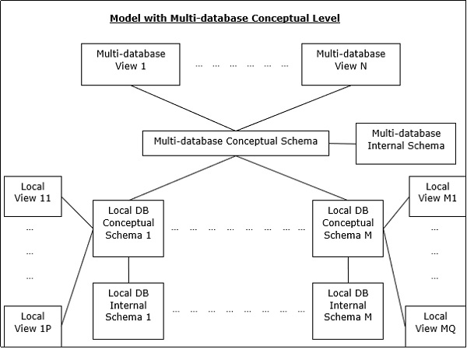
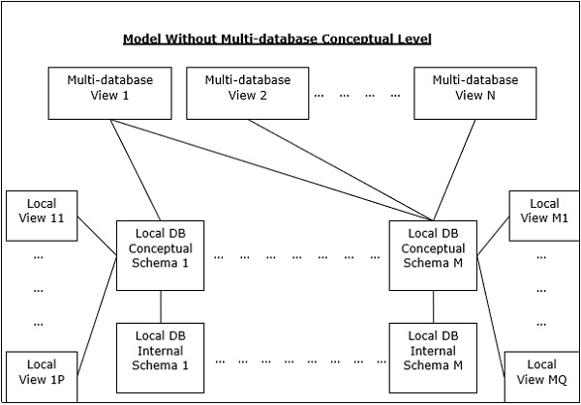

Fragmentation in Distributed DBMS

Fragmentation is a process of dividing the whole or full database into various sub tables or sub relations so that data can be stored in different systems. The small pieces of sub relations or sub tables are called fragments. These fragments are called logical data units and are stored at various sites. It must be made sure that the fragments are such that they can be used to reconstruct the original relation (i.e, there isn’t any loss of data).

In the fragmentation process, let’s say, If a table T is fragmented and is divided into a number of fragments say T1, T2, T3….TN. The fragments contain sufficient information to allow the restoration of the original table T. This restoration can be done by the use of UNION or JOIN operation on various fragments. This process is called data fragmentation. All of these fragments are independent which means these fragments cannot be derived from others. The users needn’t be logically concerned about fragmentation which means they should not concerned that the data is fragmented and this is called fragmentation Independence or we can say fragmentation transparency.

Advantages :
- As the data is stored close to the usage site, the efficiency of the database system will increase
- Local query optimization methods are sufficient for some queries as the data is available locally
- In order to maintain the security and privacy of the database system, fragmentation is advantageous

Disadvantages :
- Access speeds may be very high if data from different fragments are needed
- If we are using recursive fragmentation, then it will be very expensive

We have three methods for data fragmenting of a table:
- Horizontal fragmentation
- Vertical fragmentation
- Mixed or Hybrid fragmentation

Let’s discuss them one by one.

Horizontal fragmentation
Horizontal fragmentation refers to the process of dividing a table horizontally by assigning each row or (a group of rows) of relation to one or more fragments. These fragments are then be assigned to different sides in the distributed system. Some of the rows or tuples of the table are placed in one system and the rest are placed in other systems. The rows that belong to the horizontal fragments are specified by a condition on one or more attributes of the relation. In relational algebra horizontal fragmentation on table T, can be represented as follows:
σ_{p}(T)
where, σ is relational algebra operator for selection
p is the condition satisfied by a horizontal fragment
Note that a union operation can be performed on the fragments to construct table T. Such a fragment containing all the rows of table T is called a complete horizontal fragment.
For example, consider an EMPLOYEE table (T) :
Eno | Ename | Design | Salary | Dep
101 | A | abc | 3000 | 1
102 | B | abc | 4000 | 1
103 | C | abc | 5500 | 2
104 | D | abc | 5000 | 2
105 | E | abc | 2000 | 2
This EMPLOYEE table can be divided into different fragments like:
EMP 1 = σ_{Dep = 1} EMPLOYEE
EMP 2 = σ_{Dep = 2} EMPLOYEE
These two fragments are: T1 fragment of Dep = 1
Eno | Ename | Design | Salary | Dep
101 | A | abc | 3000 | 1
102 | B | abc | 4000 | 1
Similarly, the T2 fragment on the basis of Dep = 2 will be :
Eno | Ename | Design | Salary | Dep
103 | C | abc | 5500 | 2
104 | D | abc | 5000 | 2
105 | E | abc | 2000 | 2
Now, here it is possible to get back T as T = T1 ∪ T2 ∪ …. ∪ TN

Vertical Fragmentation

Vertical fragmentation refers to the process of decomposing a table vertically by attributes are columns. In this fragmentation, some of the attributes are stored in one system and the rest are stored in other systems. This is because each site may not need all columns of a table. In order to take care of restoration, each fragment must contain the primary key field(s) in a table. The fragmentation should be in such a manner that we can rebuild a table from the fragment by taking the natural JOIN operation and to make it possible we need to include a special attribute called Tuple-id to the schema. For this purpose, a user can use any super key. And by this, the tuples or rows can be linked together. The projection is as follows:
π_{a1, a2,…, an} (T)
where, π is relational algebra operator
a1…., an are the aatriubutes of T
T is the table (relation)
For example, for the EMPLOYEE table we have T1 as :
Eno | Ename | Design | Tuple_id
101 | A | abc | 1
102 | B | abc | 2
103 | C | abc | 3
104 | D | abc | 4
105 | E | abc | 5
For the second. sub table of relation after vertical fragmentation is given as follows :
Salary | Dep | Tuple_id
3000 | 1 | 1
4000 | 2 | 2
5500 | 3 | 3
5000 | 1 | 4
2000 | 4 | 5
This is T2 and to get back to the original T, we join these two fragments T1 and T2 as π_{EMPLOYEE} (T1 ⋈ T2)

Mixed or hybrid Fragmentation:

The combination of vertical fragmentation of a table followed by further horizontal fragmentation of some fragments is called mixed or hybrid fragmentation. For defining this type of fragmentation we use the SELECT and the PROJECT operations of relational algebra. In some situations, the horizontal and the vertical fragmentation isn’t enough to distribute data for some applications and in that conditions, we need a fragmentation called a mixed fragmentation.
Mixed fragmentation can be done in two different ways:
- The first method is to first create a set or group of horizontal fragments and then create vertical fragments from one or more of the horizontal fragments.
- The second method is to first create a set or group of vertical fragments and then create horizontal fragments from one or more of the vertical fragments.
The original relation can be obtained by the combination of JOIN and UNION operations which is given as follows:
σ_{P}(π_{a1, a2..,an}(T))
π_{a1,a2….,an} (σ_{p}(T))
For example, for our EMPLOYEE table, below is the implementation of mixed fragmentation is π_{Ename, Design} (σ_{Eno < 104}(EMPLOYEE))
The result of this fragmentation is:
Ename | Design
A | abc
B | abc
C | abc

Replication
Data Replication is the process of storing data in more than one site or node. It is useful in improving the availability of data. It is simply copying data from a database from one server to another server so that all the users can share the same data without any inconsistency. The result is a distributed database in which users can access data relevant to their tasks without interfering with the work of others.

Data replication encompasses duplication of transactions on an ongoing basis, so that the replicate is in a consistently updated state and synchronized with the source. However in data replication data is available at different locations, but a particular relation has to reside at only one location.

There can be full replication, in which the whole database is stored at every site. There can also be partial replication, in which some frequently used fragment of the database are replicated and others are not replicated.
Types of Data Replication –

- Transactional Replication – In Transactional replication users receive full initial copies of the database and then receive updates as data changes. Data is copied in real time from the publisher to the receiving database(subscriber) in the same order as they occur with the publisher therefore in this type of replication, transactional consistency is guaranteed. Transactional replication is typically used in server-to-server environments. It does not simply copy the data changes, but rather consistently and accurately replicates each change.
- Snapshot Replication – Snapshot replication distributes data exactly as it appears at a specific moment in time does not monitor for updates to the data. The entire snapshot is generated and sent to Users. Snapshot replication is generally used when data changes are infrequent. It is bit slower than transactional because on each attempt it moves multiple records from one end to the other end. Snapshot replication is a good way to perform initial synchronization between the publisher and the subscriber.
- Merge Replication – Data from two or more databases is combined into a single database. Merge replication is the most complex type of replication because it allows both publisher and subscriber to independently make changes to the database. Merge replication is typically used in server-to-client environments. It allows changes to be sent from one publisher to multiple subscribers.

Replication Schemes –

1. Full Replication – The most extreme case is replication of the whole database at every site in the distributed system. This will improve the availability of the system because the system can continue to operate as long as at least one site is up.
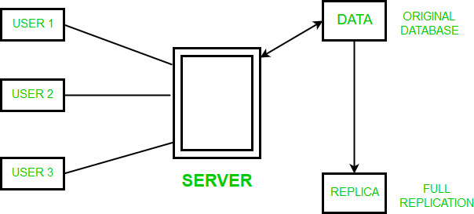
Advantages of full replication –
- High Availability of Data.
- Improves the performance for retrieval of global queries as the result can be obtained locally from any of the local site.
- Faster execution of Queries.
Disadvantages of full replication –
- Concurrency is difficult to achieve in full replication.
- Slow update process as a single update must be performed at different databases to keep the copies consistent.

2. No Replication – The other case of replication involves having No replication – that is, each fragment is stored at only one site.
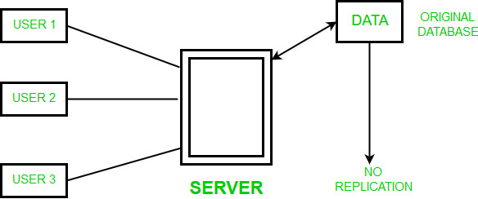
Advantages of No replication –
    - The data can be easily recovered.
    - Concurrency can be achieved in no replication.
Disadvantages of No replication –
    - Since multiple users are accessing the same server, it may slow down the execution of queries.
    - The data is not easily available as there is no replication.

3. Partial Replication – In this type of replication some fragments of the database may be replicated whereas others may not. The number of copies of the fragment may range from one to the total number of sites in the distributed system. The description of replication of fragments is sometimes called the replication schema.
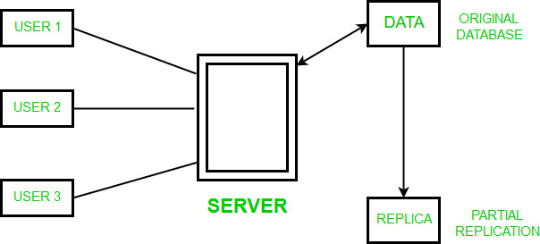
Advantages of Partial replication –
    - The number of copies of the fragment depends upon the importance of data.
ADVANTAGES OF DATA REPLICATION – Data Replication is generally performed to:
    - To provide a consistent copy of data across all the database nodes.
    - To increase the availability of data.
    - The reliability of data is increased through data replication.
    - Data Replication supports multiple users and gives high performance.
    - To remove any data redundancy,the databases are merged and slave databases are updated with outdated or incomplete data.
    - Since replicas are created there are chances that the data is found itself where the transaction is executing which reduces the data movement.
    - To perform faster execution of queries.
DISADVANTAGES OF DATA REPLICATION –
    - More storage space is needed as storing the replicas of same data at different sites consumes more space.
    - Data Replication becomes expensive when the replicas at all different sites need to be updated.
    - Maintaining Data consistency at all different sites involves complex measures.

Introduction to Object-based Databases

Traditional database applications have data-processing tasks, such as banking and payroll management, with relatively simple data types that are compatible with the relational data model. As database systems were applied to a wide range of applications, such as computer-aided design and geographic information systems, the limitations imposed by the relational model emerged as a constraint.
The rectification was the introduction of object-based databases, which assent one to deal with complex data types. In Object-Based Databases, each entity is treated as an object and represented in a table. Similar objects are classified into classes and subclasses and the relationship between two objects is maintained using the concept of inverse reference.

Obstacles in Object-Based Databases
- The first obstacle faced by programmers using the relational data model was the limited type of system supported by the relational model. Complex application domains require correspondingly complex data types, such as nested records structures, multi-valued attributes, and inheritance supported by traditional programming languages. Such features are indeed supported in ER and extended ER notation, but they had to be translated into simpler SQL data types. The object-relational data model extends the relational data model by providing a richer type system, which includes complex data types and object orientations. Relational query languages, especially SQL, need to be extended correspondingly to deal with richer type systems. Such extensions attempt to preserve the relational foundations while expanding the power of modelling—specifically, declarative access to data. Object-relational database system, that is database system based on the object-relations model, provide a convenient migration path for users of relational databases who want to use object-oriented features.
- The second obstacle was the difficulty of accessing database data from programs written in programming languages such as C++ or Java. Simply expanding the type system supported by the database was not enough to completely solve this problem. The difference between the type system of a database and the type system of a programming language makes data storage and retrieval more complex, and, and need to be minimized. Expressing database access using a language other than a programming language (SQL) again makes the programmer’s job difficult. It is desirable, for many applications, to have programming language constructs or extensions that allow direct access to the data in the database, without having to go through an intermediate language such as SQL.
Address the issue of supporting persistence for data contained in the native type system of object-oriented programming languages. In practice two approaches are used:
- Build an object-oriented database system, which is a database system that natively supports the object-oriented type system, and allows direct access to data from an object-oriented programming language using the language’s native type system.
- Automatically convert data from the programming language’s native type system into a relational representation and vice versa. Data transformation is specified using object-relational mapping.

Object-Based Data Models
The basis of the structure of a database is the data model or we can define it as a collection of conceptual tools for describing data, data relationships, data semantics, and data constraints.
- Object-oriented programming has become the dominant software-development method. This led to the development of an object-oriented data model that can be seen as an extension of the ER model with notions of encapsulation, methods(functions) and object identity.
- Inheritance, object recognition, and encapsulation(information hiding), along with methods of providing an interface to objects, are among the key concepts of object-oriented programming that have found application in data modeling.
- The object-oriented data model also supports a richer type system, including structured and collection types.
- Major database vendors currently support object-relational data models, a data model that combines the characteristics of an object-oriented data model and a relational data model.
- It extends the traditional relational model with a variety of features such as structured and collection types, as well as object orientation.

Advantages of Object-Based Databases
- Complex data and a wider variety of data types than MySQL data types.
- It’s easy to save and recover data quickly.
- Seamless integration with object-oriented programming languages.
- It is easy to model advanced real-world problems.
- Extensible with custom data types.

Disadvantages of Object-Based Databases
- Not as widely adopted as relational databases.
- No universal data model. Theoretical foundations and standards are lacking.
- Does not support the views.
- High complexity causes performance problems.
- Adequate security mechanisms and access rights to objects do not exist.

Temporal Database

A Temporal Database is a database with built-in support for handling time sensitive data. Usually, databases store information only about current state, and not about past states. For example in a employee database if the address or salary of a particular person changes, the database gets updated, the old value is no longer there. However for many applications, it is important to maintain the past or historical values and the time at which the data was updated. That is, the knowledge of evolution is required. That is where temporal databases are useful. It stores information about the past, present and future. Any data that is time dependent is called the temporal data and these are stored in temporal databases.
Temporal Databases store information about states of the real world across time. Temporal Database is a database with built-in support for handling data involving time. It stores information relating to past, present and future time of all events.

Examples Of Temporal Databases
- Healthcare Systems: Doctors need the patients’ health history for proper diagnosis. Information like the time a vaccination was given or the exact time when fever goes high etc.
- Insurance Systems: Information about claims, accident history, time when policies are in effect needs to be maintained.
- Reservation Systems: Date and time of all reservations is important.

Temporal Aspects
There are two different aspects of time in temporal databases.
- Valid Time: Time period during which a fact is true in real world, provided to the system.
- Transaction Time: Time period during which a fact is stored in the database, based on transaction serialization order and is the timestamp generated automatically by the system.

Temporal Relation
Temporal Relation is one where each tuple has associated time; either valid time or transaction time or both associated with it.
- Uni-Temporal Relations: Has one axis of time, either Valid Time or Transaction Time.
- Bi-Temporal Relations: Has both axis of time – Valid time and Transaction time. It includes Valid Start Time, Valid End Time, Transaction Start Time, Transaction End Time.

Valid Time Example
Now let’s see an example of a person, John:
- John was born on April 3, 1992 in Chennai.
- His father registered his birth after three days on April 6, 1992.
- John did his entire schooling and college in Chennai.
- He got a job in Mumbai and shifted to Mumbai on June 21, 2015.
- He registered his change of address only on Jan 10, 2016.

John’s Data In Non-Temporal Database
In a non-temporal database, John’s address is entered as Chennai from 1992. When he registers his new address in 2016, the database gets updated and the address field now shows his Mumbai address. The previous Chennai address details will not be available. So, it will be difficult to find out exactly when he was living in Chennai and when he moved to Mumbai.
Date | Real world event | Address
April 3, 1992 | John is born
April 6, 1992 | John’s father registered his birth | Chennai
June 21, 2015 | John gets a job | Chennai
Jan 10, 2016 | John registers his new address | Mumbai
Non temporal Database

Uni-Temporal Relation (Adding Valid Time To John’s Data)
To make the above example a temporal database, we’ll be adding the time aspect also to the database. First let’s add the valid time which is the time for which a fact is true in real world. Valid time is the time for which a fact is true in the real world. A valid time period may be in the past, span the current time, or occur in the future.
The valid time temporal database contents look like this:
Name, City, Valid From, Valid Till

In our example, john was born on 3rd April 1992. Even though his father registered his birth three days later, the valid time entry would be 3rd April of 1992. There are two entries for the valid time. The Valid Start Time and the Valid End Time. So in this case 3rd April 1992 is the valid start time. Since we do not know the valid end time we add it as infinity.

Johns father registers his birth on 6th April 1992, a new database entry is made:
Person(John, Chennai, 3-Apr-1992, ∞).

Similarly John changes his address to Mumbai on 10th Jan 2016. However, he has been living in Mumbai from 21st June of the previous year. So his valid time entry would be 21 June 2015.
On January 10, 2016 John reports his new address in Mumbai:
Person(John, Mumbai, 21-June-2015, ∞).
The original entry is updated.
Person(John, Chennai, 3-Apr-1992, 20-June-2015).
The table will look something like this with two additional entries:

Name | City | Valid From | Valid Till
John | Chennai | April 3, 1992 | June 20, 2015
John | Mumbai | June 21, 2015 | ∞
Uni-temporal Database

Bi-Temporal Relation (John’s Data Using Both Valid And Transaction Time)
Next we’ll see a bi-temporal database which includes both the valid time and transaction time. Transaction time records the time period during which a database entry is made. So, now the database will have four additional entries the valid from, valid till, transaction entered and transaction superseded.

The database contents look like this:
Name, City, Valid From, Valid Till, Entered, Superseded
First, when John’s father records his birth the valid start time would be 3rd April 1992, his actual birth date. However, the transaction entered time would be 6th April 1992.
Johns father registers his birth on 6th April 1992:
Person(John, Chennai, 3-Apr-1992, ∞, 6-Apr-1992, ∞).
Similarly, when john registers his change of address in Mumbai, a new entry is made. The valid from time for this entry is 21st June 2015, the actual date from which he started living in Mumbai. whereas the transaction entered time would be 10th January 2016. We do not know how long he’ll be living in Mumbai. So the transaction end time and the valid end time would be infinity. At the same time the original entry is updated with the valid till time and the transaction superseded time.
On January 10, 2016 John reports his new address in Mumbai:
Person(John, Mumbai, 21-June-2015, ∞, 10-Jan-2016, ∞).
The original entry is updated.
Person(John, Chennai, 3-Apr-1992, 20-June-2015, 6-Apr-1992, 10-Jan-2016).
Now the database looks something like this:

Name | City | Valid From | Valid Till | Entered | Superseded
John | Chennai | April 3, 1992 | June 20, 2015 | April 6, 1992 | Jan 10, 2016
John | Mumbai | June 21, 2015 | ∞ | Jan 10, 2016 | ∞
Bi-temporal Database

Advantages
The main advantages of this bi-temporal relations is that it provides historical and roll back information. For example, you can get the result for a query on John’s history, like: Where did John live in the year 2001?. The result for this query can be got with the valid time entry. The transaction time entry is important to get the rollback information.
- Historical Information – Valid Time.
- Rollback Information – Transaction Time.

Products Using Temporal Databases
The popular products that use temporal databases include:
- Oracle.
- Microsoft SQL Server.
- IBM DB2.

Spatial Databases

A spatial database is a database that is enhanced to store and access spatial data or data that defines a geometric space. These data are often associated with geographic locations and features or constructed features like cities. Data on spatial databases are stored as coordinates, points, lines, polygons, and topology. Some spatial databases handle more complex data like three-dimensional objects, topological coverage, and linear networks.

The Open Geospatial Consortium (OGC) developed the Simple Features specification (first released in 1997) and sets standards for adding spatial functionality to database systems. The SQL/MM Spatial ISO/IEC standard is a part of the SQL/MM multimedia standard and extends the Simple Features standard with data types that support circular interpolations.
Spatial Databases:
A database that needs to store and query spatial objects, e.g.
• Point: a house, a monument
• Line: a road segment, a road network
• Polygon: a county, a voting area
Types of spatial data
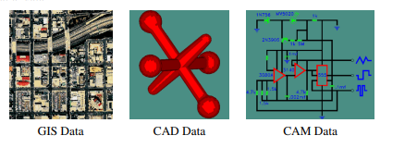
Spatial Database Management Systems:
- A Database Management System that manages data existing in some space
- 2D or 2.5D
• Integrated circuits: VLSI design
• Geographic space (surface of the Earth): GIS, urban planning _
- 2.5 D: Elevation
- 3D
• Medicine: Brain models
• Biological research: Molecule structures
• Architecture: CAD
• Ground models: Geology
- Supporting technology able to manage large collections of geometric objects
- Major commercial and open-source DBMSs provide spatial support

What makes it different from other database systems?
Common database systems use indexes for a faster and more efficient search and access of data. This index, however, is not fit for spatial queries. Instead, spatial databases use something like a unique index called a spatial index to speed up database performance. Spatial indexing is very much required because a system should be able to retrieve data from a large collection of objects without really searching the whole bunch. It should also support relationships between connecting objects from different classes in a better manner than just filtering.
Aside from the indexes, spatial databases also offer spatial data types in their data model and query language. These databases require special kinds of data types to provide a fundamental abstraction and model the structure of the geometric objects with their corresponding relationships and operations in the spatial environment. Without these kinds of data types, the system would not be able to support the kind of modeling a spatial database offers.
Why Spatial Databases?
- Queries to databases are posed in high level declarative manner (usually using SQL)
- SQL is popular in the commercial database world
- Standard SQL operates on relatively simple data types
- Additional spatial data types and operations can be defined in spatial database
- SQL was extended to support spatial data types and operations, e.g., OGC Simple Features for SQL
- A DBMS is a way of storing information in a manner that
• Enforces consistency
• Facilitates access
• Allows users to relate data from multiple tables together.

Characteristics of Spatial Database
A spatial database system has the following characteristics
- It is a database system
- It offers spatial data types (SDTs) in its data model and query language.
- It supports spatial data types in its implementation, providing at least spatial indexing and efficient algorithms for spatial join.

Example
A road map is a visualization of geographic information. A road map is a 2-dimensional object which contains points, lines, and polygons that can represent cities, roads, and political boundaries such as states or provinces.
In general, spatial data can be of two types −
- Vector data: This data is represented as discrete points, lines and polygons
- Rastor data: This data is represented as a matrix of square cells.
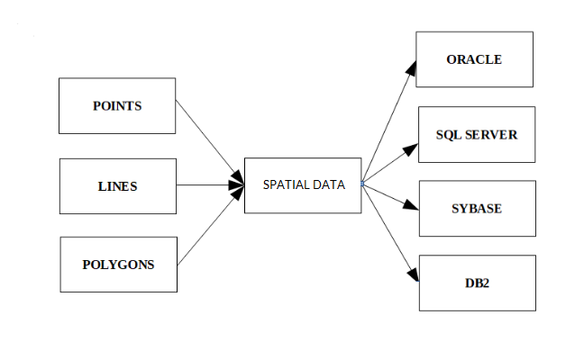
The spatial data in the form of points, lines, polygons etc. is used by many different databases as shown above.

Application Areas
- Street network-based
• Vehicle routing and scheduling (cars, planes, trains)
• Location analysis
- Natural resource-based
• Management of areas: agricultural lands, forests, recreation resources, wildlife habitat analysis, migration routes planning...
• Environmental impact analysis
• Toxic facility siting
• Groundwater modeling,
- Land parcel-based
• Zoning, subdivision plan review
• Environmental impact statements
• Water quality management
• Facility management: electricity, gaz, clean water, used water, network

Multimedia Database

Multimedia database is the collection of interrelated multimedia data that includes text, graphics (sketches, drawings), images, animations, video, audio etc and have vast amounts of multisource multimedia data. The framework that manages different types of multimedia data which can be stored, delivered and utilized in different ways is known as multimedia database management system. There are three classes of the multimedia database which includes static media, dynamic media and dimensional media.

Content of Multimedia Database management system :
- Media data – The actual data representing an object.
- Media format data – Information such as sampling rate, resolution, encoding scheme etc. about the format of the media data after it goes through the acquisition, processing and encoding phase.
- Media keyword data – Keywords description relating to the generation of data. It is also known as content descriptive data. Example: date, time and place of recording.
- Media feature data – Content dependent data such as the distribution of colors, kinds of texture and different shapes present in data.

Types of multimedia applications based on data management characteristic are :
- Repository applications – A Large amount of multimedia data as well as meta-data(Media format date, Media keyword data, Media feature data) that is stored for retrieval purpose, e.g., Repository of satellite images, engineering drawings, radiology scanned pictures.
- Presentation applications – They involve delivery of multimedia data subject to temporal constraint. Optimal viewing or listening requires DBMS to deliver data at certain rate offering the quality of service above a certain threshold. Here data is processed as it is delivered. Example: Annotating of video and audio data, real-time editing analysis.
- Collaborative work using multimedia information – It involves executing a complex task by merging drawings, changing notifications. Example: Intelligent healthcare network.

There are still many challenges to multimedia databases, some of which are :
- Modelling – Working in this area can improve database versus information retrieval techniques thus, documents constitute a specialized area and deserve special consideration.
- Design – The conceptual, logical and physical design of multimedia databases has not yet been addressed fully as performance and tuning issues at each level are far more complex as they consist of a variety of formats like JPEG, GIF, PNG, MPEG which is not easy to convert from one form to another.
- Storage – Storage of multimedia database on any standard disk presents the problem of representation, compression, mapping to device hierarchies, archiving and buffering during input-output operation. In DBMS, a ”BLOB”(Binary Large Object) facility allows un typed bitmaps to be stored and retrieved.
- Performance – For an application involving video playback or audio-video synchronization, physical limitations dominate. The use of parallel processing may alleviate some problems but such techniques are not yet fully developed. Apart from this multimedia database consume a lot of processing time as well as bandwidth.
- Queries and retrieval –For multimedia data like images, video, audio accessing data through query opens up many issues like efficient query formulation, query execution and optimization which need to be worked upon.

Areas where multimedia database is applied are :
- Documents and record management : Industries and businesses that keep detailed records and variety of documents. Example: Insurance claim record.
- Knowledge dissemination : Multimedia database is a very effective tool for knowledge dissemination in terms of providing several resources. Example: Electronic books.
- Education and training : Computer-aided learning materials can be designed using multimedia sources which are nowadays very popular sources of learning. Example: Digital libraries.
- Marketing, advertising, retailing, entertainment and travel. Example: a virtual tour of cities.
- Real-time control and monitoring : Coupled with active database technology, multimedia presentation of information can be very effective means for monitoring and controlling complex tasks Example: Manufacturing operation control.
- Marketing
- Advertisement
- Retailing
- Entertainment
- Travel

XML Databases

An XML database is a data persistence software system that allows data to be stored in XML format. These data can then be queried, exported and serialized into the desired format. XML databases are usually associated with document-oriented databases.

Two major classes of XML database exist

1. XML-enabled: these may either map XML to traditional database structures (such as a relational database), accepting XML as input and rendering XML as output, or more recently support native XML types within the traditional database. This term implies that the database processes the XML itself (as opposed to relying on middleware).

2. Native XML (NXD): the internal model of such databases depends on XML and uses XML documents as the fundamental unit of storage, which are, however, not necessarily stored in the form of text files.

Rationale for XML in databases
O'Connell gives one reason for the use of XML in databases: the increasingly common use of XML for data transport, which has meant that "data is extracted from databases and put into XML documents and vice-versa" It may prove more efficient (in terms of conversion costs) and easier to store the data in XML format. In content-based applications, the ability of the native XML database also minimizes the need for extraction or entry of metadata to support searching and navigation. In a native XML environment, the entire content store becomes metadata through query languages such as XPath and XQuery, including content, attributes and relationships within the XML (find string "XABr" within element <para> containing attribute 123 having value "P" or "Q", only within parent Y and siblings F or G.) While this level of search capability is possible in external metadata, it requires more complex and difficult processing to reproduce the content tree in metadata.

XML Enabled databases:

XML enabled databases typically offer one or more of the following approaches to storing XML within the traditional relational structure:

1. XML is stored into a CLOB (Character large object)
2. XML is `shredded` into a series of Tables based on a Schema
3. XML is stored into a native XML Type as defined by the ISO

RDBMS that support the ISO XML Type are:

1. IBM DB2 (pureXML)
2. Microsoft SQL Server
3. Oracle Database
4. PostgreSQL
Typically an XML enabled database is best suited where the majority of data are non-XML. For datasets where the majority of data are XML a Native XML Database is better suited.

Example of XML Type Query in IBM DB2 SQL

SELECT id, vol, xmlquery('$j/name', passing journal AS "j") AS name FROM journals
WHERE xmlexists('$j[licence="CreativeCommons"]', passing journal AS "j")

Native XML databases:

The term "native XML database" (NXD) can lead to confusion. Many NXDs do not function as standalone databases at all, and do not really store the native (text) form.

The formal definition from the XML:DB initiative (which appears to be inactive since 2003)
states that a native XML database:

• Defines a (logical) model for an XML document — as opposed to the data in that document — and stores and retrieves documents according to that model. At a minimum, the model must include elements, attributes, PCDATA, and document order. Examples of such models include the XPath data model, the XML Infoset, and the models implied by the DOM and the events in SAX 1.0.

• Has an XML document as its fundamental unit of (logical) storage, just as a relational database has a row in a table as its fundamental unit of (logical) storage.

• Need not have any particular underlying physical storage model. For example, NXDs can use relational, hierarchical, or object-oriented database structures, or use a proprietary storage format (such as indexed, compressed files). Additionally, many XML databases provide a logical model of grouping documents, called "collections". Databases can set up and manage many collections at one time. In some implementations, a hierarchy of collections can exist, much in the same way that an operating system's directory-structure works.

All XML databases now support at least one form of querying syntax. Minimally, just about all of them support XPath for performing queries against documents or collections of documents. XPath provides a simple pathing system that allows users to identify nodes that match a particular set of criteria.

In addition to XPath, many XML databases support XSLT as a method of transforming documents or query-results retrieved from the database. XSLT provides a declarative language written using an XML grammar. It aims to define a set of XPath filters that can transform documents (in part or in whole) into other formats including plain text, XML, or HTML.

Many XML databases also support XQuery to perform querying. XQuery includes XPath as a node-selection method, but extends XPath to provide transformational capabilities. Users sometimes refer to its syntax as "FLWOR" (pronounced 'Flower') because the query may include the following clauses: 'for', 'let', 'where', 'order by' and 'return'. Traditional RDBMS vendors (who traditionally had SQL-only engines), are now shipping with hybrid SQL and XQuery engines. Hybrid SQL/XQuery engines help to query XML data alongside the relational data, in the same query expression. This approach helps in combining relational and XML data.

Most XML Databases support a common vendor neutral API called the XQuery API for Java (XQJ). The XQJ API was developed at the JCP as a standard interface to an XML/XQuery data source, enabling a Java developer to submit queries conforming to the World Wide Web Consortium (W3C) XQuery 1.0 specification and to process the results of such queries. Ultimately the XQJ API is to XML Databases and XQuery as the JDBC API is to Relational
Databases and SQL.
XML schema

Databases have schemas, which are used to constrain what information can be stored in the database and to constrain the data types of the stored information. In contrast, by default, XML documents can be created without any associated schema: an element may then have any subelement or attribute. While such freedom may occasionally be acceptable given the self describing nature of the data format, it is not generally useful when XML documents must be processed automatically as part of an application, or even when large amounts of related data are to be formatted in XML. Here, we describe the first schema-definition language included as part of the XML standard, the Document Type Definition, as well as its more recently defined replacement, XML Schema. Another XML schema-definition language called Relax NG is also in use

Document Type Definition

The document type definition (DTD) is an optional part of anXML document. The main purpose of a DTD is much like that of a schema: to constrain and type the information present in the document. However, the DTD does not in fact constrain types in the sense of basic types like integer or string. Instead, it constrains only the appearance of subelements and attributes within an element. The DTD is primarily a list of rules for what pattern of subelements may appear within an element. Figure 23.9 shows a part of an example DTD for a university information document;
the XML document in Figure 23.1 conforms to this DTD. Each declaration is in the form of a regular expression for the subelements of an element. Thus, in the DTD a university element consists of one or more course, department, or instructor elements; the | operator specifies ―or

<!DOCTYPE university [
<!ELEMENT university ( (department|course|instructor|teaches)+)>
<!ELEMENT department ( dept name, building, budget)>
<!ELEMENT course ( course id, title, dept name, credits)>
<!ELEMENT instructor (IID, name, dept name, salary)>
<!ELEMENT teaches (IID, course id)>
<!ELEMENT dept name( #PCDATA )>
<!ELEMENT building( #PCDATA )>
<!ELEMENT budget( #PCDATA )>
<!ELEMENT course id ( #PCDATA )>
<!ELEMENT title ( #PCDATA )>
<!ELEMENT credits( #PCDATA )>
<!ELEMENT IID( #PCDATA )>
<!ELEMENT name( #PCDATA )>
<!ELEMENT salary( #PCDATA )>
] >
while the + operator specifies ―one or more.‖ Although not shown here, the operator is used to specify ―zero or more,‖ while the ? operator is used to specify an optional element (that is, ―zero or one‖). The course element contains subelements course id, title, dept name, and credits (in that order). Similarly, department and instructor have the attributes of their relational schema defined as subelements in the DTD. Finally, the elements course id, title, dept name, credits, building, budget, IID, name, and salary are all declared to be of type #PCDATA. The keyword #PCDATA indicates text data; it derives its name, historically, from ―parsed character data.‖ Two other special type declarations are empty, which says that the element has no contents, and any, which says that there is no constraint on the subelements of the element; that is, any elements, even those not mentioned in the DTD, can occur as subelements of the element. The absence of a declaration for an element is equivalent to explicitly declaring the type as any. The allowable attributes for each element are also declared in the DTD. Unlike subelements, no order is imposed on attributes. Attributes may be specified to be of type CDATA, ID, IDREF, or IDREFS; the type CDATA simply says that the attribute contains character data, while the other three are not so simple; they are explained in more detail shortly. For instance, the following line from a DTD specifies that element course has an attribute of type course id, and a value must be present for this attribute:

<!ATTLIST course course id CDATA #REQUIRED>

Attributes must have a type declaration and a default declaration. The default
declaration can consist of a default value for the attribute or #REQUIRED, meaning
<!DOCTYPE university-3 [
<!ELEMENT university ( (department|course|instructor)+)>
<!ELEMENT department ( building, budget )>
<!ATTLIST department
dept name ID #REQUIRED >
<!ELEMENT course (title, credits )>
<!ATTLIST course
course id ID #REQUIRED
dept name IDREF #REQUIRED
instructors IDREFS #IMPLIED >
<!ELEMENT instructor ( name, salary )>
<!ATTLIST instructor
IID ID #REQUIRED >
dept name IDREF #REQUIRED >
· · · declarations for title, credits, building,
budget, name and salary · · ·
] >

that a value must be specified for the attribute in each element, or #IMPLIED, meaning that no default value has been provided, and the document may omit this attribute. If an attribute has a default value, for every element that does not specify a value for the attribute, the default value is filled in automatically when the XML document is read. An attribute of type ID provides a unique identifier for the element; a value that occurs in an ID attribute of an element must not occur in any other element in the same document. At most one attribute of an element is permitted to be of type ID. (We renamed the attribute ID of the instructor relation to IID in the XML representation, in order to avoid confusion with the type ID.) An attribute of type IDREF is a reference to an element; the attribute must contain a value that appears in the ID attribute of some element in the document. The type IDREFS allows a list of references, separated by spaces. Figure shows an example DTD in which identifiers of course, department and instructor are represented by ID attributes, and relationships between them are represented by IDREF and IDREFS attributes. The course elements use course id as their identifier attribute; to do so, course id has been made an attribute of course instead of a subelement. Additionally, each course element also contains an IDREF of the department corresponding to the course, and an IDREFS attribute instructors identifying the instructors who teach the course. The department elements have an identifier attribute called dept name. The instructor elements have an identifier attribute called IID, and an IDREF attribute dept name identifying the department to which the instructor belongs.

<university-3>
<department dept name=―Comp. Sci.‖>
<building> Taylor </building>
<budget> 100000 </budget>
</department>
<department dept name=―Biology‖>
<building> Watson </building>
<budget> 90000 </budget>
</department>
<course course id=―CS-101‖ dept name=―Comp. Sci‖
instructors=―10101 83821‖>
<title> Intro. to Computer Science </title>
<credits> 4 </credits>
</course>
<course course id=―BIO-301‖ dept name=―Biology‖
instructors=―76766‖>
<title> Genetics </title>
<credits> 4 </credits>
</course>
<instructor IID=―10101‖ dept name=―Comp. Sci.‖>
<name> Srinivasan </name>
<salary> 65000 </salary>
</instructor>
<instructor IID=―83821‖ dept name=―Comp. Sci.‖>
<name> Brandt </name>
<salary> 72000 </salary>
</instructor>
<instructor IID=―76766‖ dept name=―Biology‖>
<name> Crick </name>
<salary> 72000 </salary>
</instructor>
</university-3>

NoSQL Database

What is NoSQL?
NoSQL Database is a non-relational Data Management System, that does not require a fixed schema. It avoids joins, and is easy to scale. The major purpose of using a NoSQL database is for distributed data stores with humongous data storage needs. NoSQL is used for Big data and real-time web apps. For example, companies like Twitter, Facebook and Google collect terabytes of user data every single day.

NoSQL database stands for “Not Only SQL” or “Not SQL.” Though a better term would be “NoREL”, NoSQL caught on. Carl Strozz introduced the NoSQL concept in 1998.

Traditional RDBMS uses SQL syntax to store and retrieve data for further insights. Instead, a NoSQL database system encompasses a wide range of database technologies that can store structured, semi-structured, unstructured and polymorphic data. Let’s understand about NoSQL with a diagram in this NoSQL database tutorial:
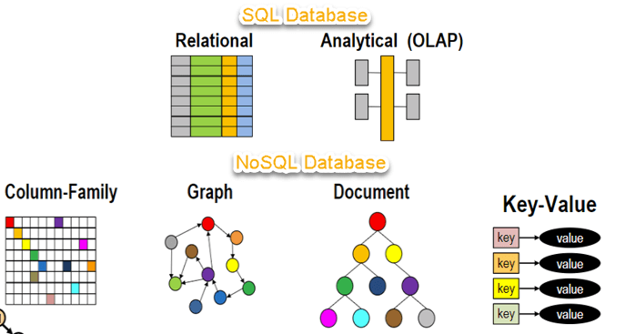

Why NoSQL?
The concept of NoSQL databases became popular with Internet giants like Google, Facebook, Amazon, etc. who deal with huge volumes of data. The system response time becomes slow when you use RDBMS for massive volumes of data. To resolve this problem, we could “scale up” our systems by upgrading our existing hardware. This process is expensive. The alternative for this issue is to distribute database load on multiple hosts whenever the load increases. This method is known as “scaling out.”
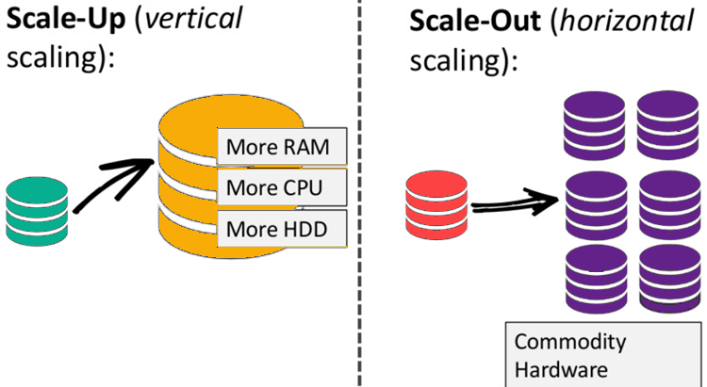
NoSQL database is non-relational, so it scales out better than relational databases as they are designed with web applications in mind.

Brief History of NoSQL Databases
- 1998- Carlo Strozzi use the term NoSQL for his lightweight, open-source relational database
- 2000- Graph database Neo4j is launched
- 2004- Google BigTable is launched
- 2005- CouchDB is launched
- 2007- The research paper on Amazon Dynamo is released
- 2008- Facebooks open sources the Cassandra project
- 2009- The term NoSQL was reintroduced

Types of NoSQL Databases
NoSQL Databases are mainly categorized into four types: Key-value pair, Column-oriented, Graph-based and Document-oriented. Every category has its unique attributes and limitations. None of the above-specified database is better to solve all the problems. Users should select the database based on their product needs.
Types of NoSQL Databases:
- Key-value Pair Based
- Column-oriented Graph
- Graphs based
- Document-oriented
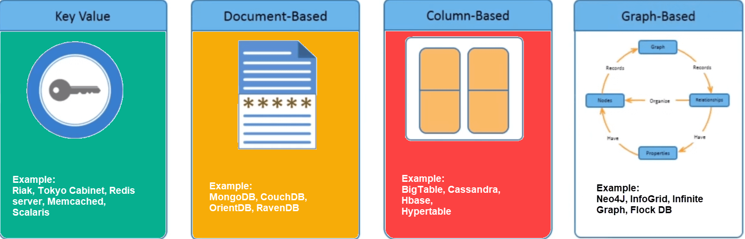

Key Value Pair Based
Data is stored in key/value pairs. It is designed in such a way to handle lots of data and heavy load.
Key-value pair storage databases store data as a hash table where each key is unique, and the value can be a JSON, BLOB(Binary Large Objects), string, etc.
For example, a key-value pair may contain a key like “Website” associated with a value like “Guru99”.
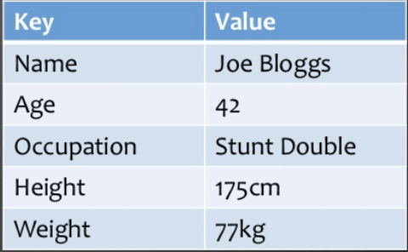

It is one of the most basic NoSQL database example. This kind of NoSQL database is used as a collection, dictionaries, associative arrays, etc. Key value stores help the developer to store schema-less data. They work best for shopping cart contents.
Redis, Dynamo, Riak are some NoSQL examples of key-value store DataBases. They are all based on Amazon’s Dynamo paper.

Column-based
Column-oriented databases work on columns and are based on BigTable paper by Google. Every column is treated separately. Values of single column databases are stored contiguously.
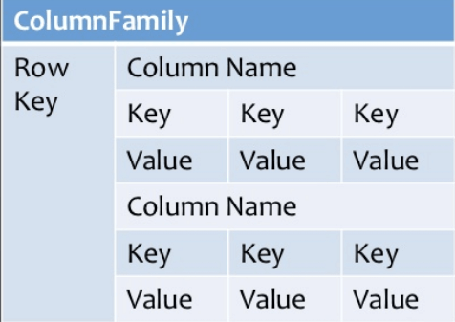
Column based NoSQL database
They deliver high performance on aggregation queries like SUM, COUNT, AVG, MIN etc. as the data is readily available in a column. Column-based NoSQL databases are widely used to manage data warehouses, business intelligence, CRM, Library card catalogs, HBase, Cassandra, HBase, Hypertable are NoSQL query examples of column based database.

Document-Oriented:
Document-Oriented NoSQL DB stores and retrieves data as a key value pair but the value part is stored as a document. The document is stored in JSON or XML formats. The value is understood by the DB and can be queried.
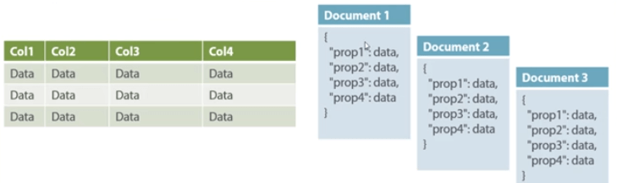
Relational Vs. Document
In this diagram on your left you can see we have rows and columns, and in the right, we have a document database which has a similar structure to JSON. Now for the relational database, you have to know what columns you have and so on. However, for a document database, you have data store like JSON object. You do not require to define which make it flexible. The document type is mostly used for CMS systems, blogging platforms, real-time analytics & e-commerce applications. It should not use for complex transactions which require multiple operations or queries against varying aggregate structures. Amazon SimpleDB, CouchDB, MongoDB, Riak, Lotus Notes, MongoDB, are popular Document originated DBMS systems.

Graph-Based:
A graph type database stores entities as well the relations amongst those entities. The entity is stored as a node with the relationship as edges. An edge gives a relationship between nodes. Every node and edge has a unique identifier.
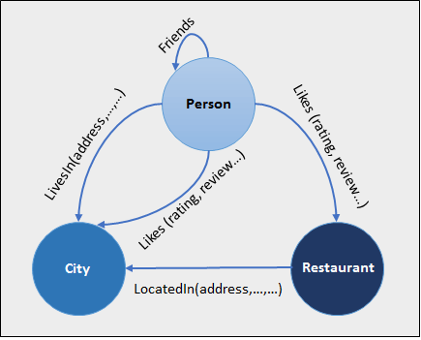
Compared to a relational database where tables are loosely connected, a Graph database is a multi-relational in nature. Traversing relationship is fast as they are already captured into the DB, and there is no need to calculate them.
Graph base database mostly used for social networks, logistics, spatial data.
Neo4J, Infinite Graph, OrientDB, FlockDB are some popular graph-based databases.

Query Mechanism tools for NoSQL
The most common data retrieval mechanism is the REST-based retrieval of a value based on its key/ID with GET resource
Document store Database offers more difficult queries as they understand the value in a key-value pair. For example, CouchDB allows defining views with MapReduce

What is the CAP Theorem?
CAP theorem is also called brewer’s theorem. It states that is impossible for a distributed data store to offer more than two out of three guarantees
- Consistency
- Availability
- Partition Tolerance
Consistency:
The data should remain consistent even after the execution of an operation. This means once data is written, any future read request should contain that data. For example, after updating the order status, all the clients should be able to see the same data.
Availability:
The database should always be available and responsive. It should not have any downtime.
Partition Tolerance:
Partition Tolerance means that the system should continue to function even if the communication among the servers is not stable. For example, the servers can be partitioned into multiple groups which may not communicate with each other. Here, if part of the database is unavailable, other parts are always unaffected.

Advantages of NoSQL
- Can be used as Primary or Analytic Data Source
- Big Data Capability
- No Single Point of Failure
- Easy Replication
- No Need for Separate Caching Layer
- It provides fast performance and horizontal scalability.
- Can handle structured, semi-structured, and unstructured data with equal effect
- Object-oriented programming which is easy to use and flexible
- NoSQL databases don’t need a dedicated high-performance server
- Support Key Developer Languages and Platforms
- Simple to implement than using RDBMS
- It can serve as the primary data source for online applications.
- Handles big data which manages data velocity, variety, volume, and complexity
- Excels at distributed database and multi-data center operations
- Eliminates the need for a specific caching layer to store data
- Offers a flexible schema design which can easily be altered without downtime or service disruption

Disadvantages of NoSQL
- No standardization rules
- Limited query capabilities
- RDBMS databases and tools are comparatively mature
- It does not offer any traditional database capabilities, like consistency when multiple transactions are performed simultaneously.
- When the volume of data increases it is difficult to maintain unique values as keys become difficult
- Doesn’t work as well with relational data
- The learning curve is stiff for new developers
- Open source options so not so popular for enterprises.

Features of NoSQL
Non-relational
- NoSQL databases never follow the relational model
- Never provide tables with flat fixed-column records
- Work with self-contained aggregates or BLOBs
- Doesn’t require object-relational mapping and data normalization
- No complex features like query languages, query planners,referential integrity joins, ACID
Schema-free
- NoSQL databases are either schema-free or have relaxed schemas
- Do not require any sort of definition of the schema of the data
- Offers heterogeneous structures of data in the same domain
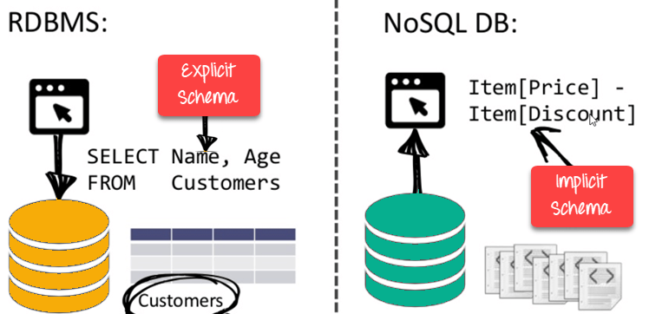
NoSQL is Schema-Free
Simple API
- Offers easy to use interfaces for storage and querying data provided
- APIs allow low-level data manipulation & selection methods
- Text-based protocols mostly used with HTTP REST with JSON
- Mostly used no standard based NoSQL query language
- Web-enabled databases running as internet-facing services
Distributed
- Multiple NoSQL databases can be executed in a distributed fashion
- Offers auto-scaling and fail-over capabilities
- Often ACID concept can be sacrificed for scalability and throughput
- Mostly no synchronous replication between distributed nodes Asynchronous Multi-Master Replication, peer-to-peer, HDFS Replication
- Only providing eventual consistency
- Shared Nothing Architecture. This enables less coordination and higher distribution.
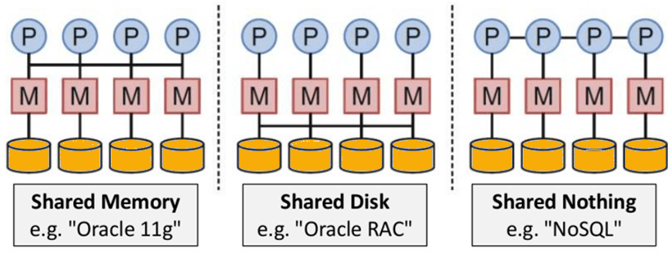
NoSQL is Shared Nothing.
Complex-free working:
Unlike SQL databases, NoSQL databases are not complicated. They store data in an unstructured or a semi-structured form that requires no relational or tabular arrangement. Perhaps they are easier to use and can be accomplished by all.

Better Scalability:
One of the most prominent features of such a database is that it has high scalability that makes it suitable for large amounts of data. Needless to mention that the contemporary data scientists often prefer to work with NoSQL databases due to this feature since it allows them to accommodate humongous data without rupturing its efficacy.

Flexible to accommodate

Since such databases can accommodate heterogeneous data that requires no structuring, they are claimed to be flexible in terms of their usage and reliability.

Durable
If durability is not one of its most striking features, then what is? NoSQL databases are highly durable as they can accommodate data ranging from heterogeneous to homogeneous. Not only can they accommodate structured data, but they can also incorporate unstructured data that requires no query language. Undoubtedly, these databases are durable and efficient.

Applications of NoSQL Databases

- Data Mining

When it comes to data mining, NoSQL databases are useful in retrieving information for data mining uses. Particularly when it’s about large amounts of data, NoSQL databases store data points in both structured and unstructured formats leading to efficient storage of big data. Perhaps when a user wishes to mine a particular dataset from large amounts of data, one can make use of NoSQL databases, to begin with. Data is the building block of technology that has led mankind to such great heights. Therefore, one of the most essential fields where NoSQL databases can be put to use is data mining and data storage.

- Social Media Networking Sites

Social media is full of data, both structured and unstructured. A field that is loaded with tons of data to be discovered, social media is one of the most effective applications of NoSQL databases. From comments to posts, user-related information to advertising, social media marketing requires NoSQL databases to be implemented in certain ways to retrieve useful information that can be helpful in certain ways. Social media sites like Facebook and Instagram often approach open-source NoSQL databases to extract data that helps them keep track of their users and the activities going on around their platforms.

- Software Development

The third application that we will be looking at is software development. Software development requires extensive research on users and the needs of the masses that are met through software development. However, a developer must be able to scan through data that is available. Perhaps NoSQL databases are always useful in helping software developers keep a tab on their users, their details, and other user-related data that is important to be noted. That said, NoSQL databases are surely helpful in software development.

